Create IBM Watson IOT Platform And Device

Date:14 November 2022

Team ID: PNT2022TMID28791

Project Name:Smart solutions for railways

Step-1:Creating IBM Cloud

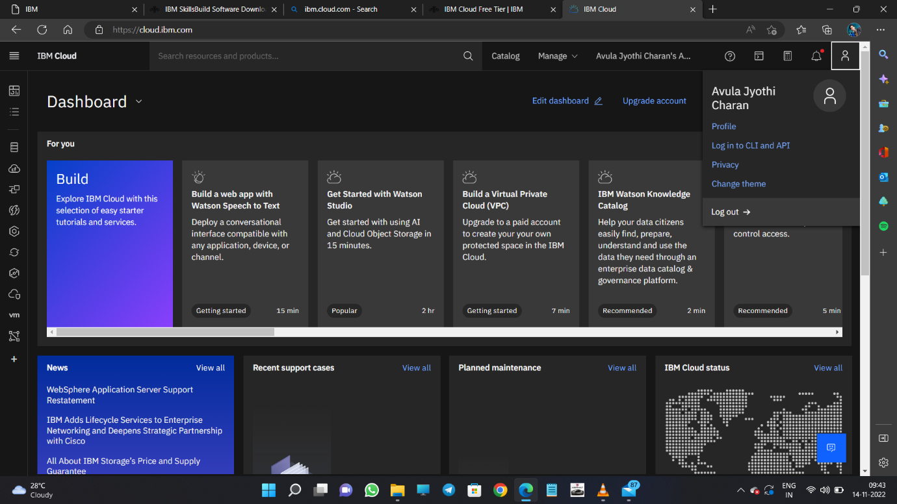

Step-2:Configure the IBM CLOUD service and creating IOT platform

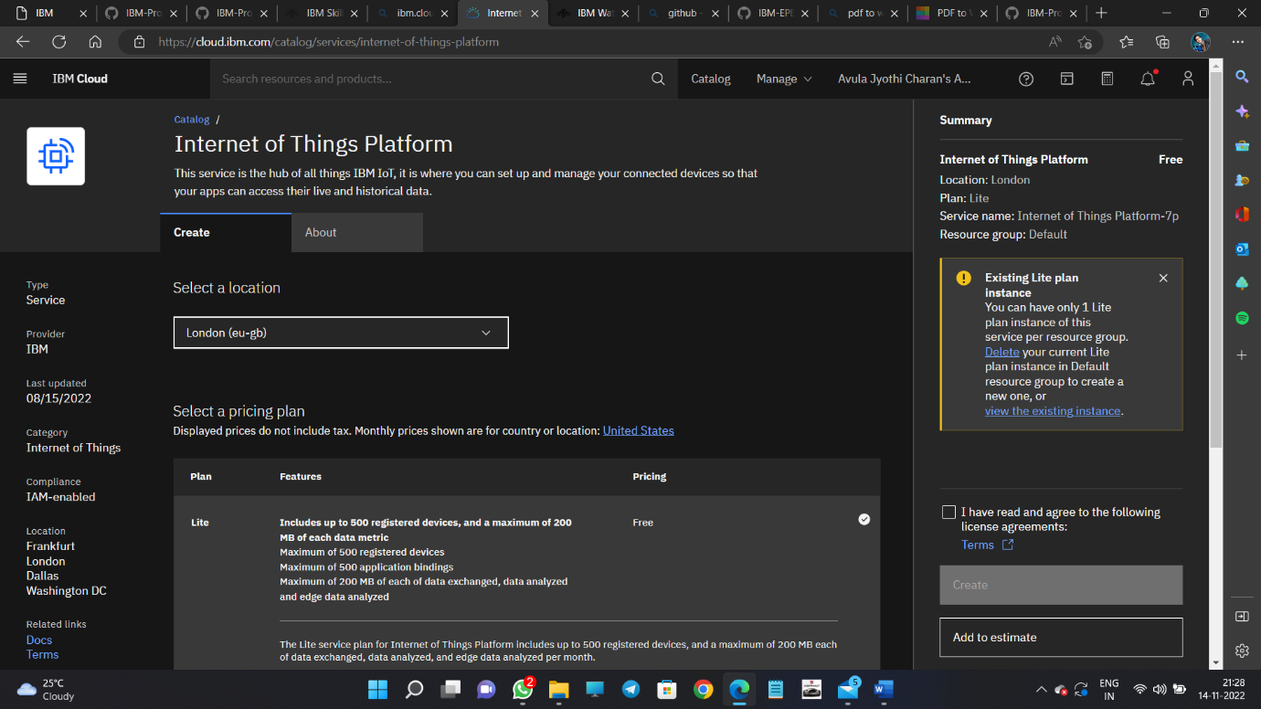

Step-3:IBM Watson IOT platform acts as the mediator to connect the web applications to IOT devices/hence launching IBM Watson IOT platform

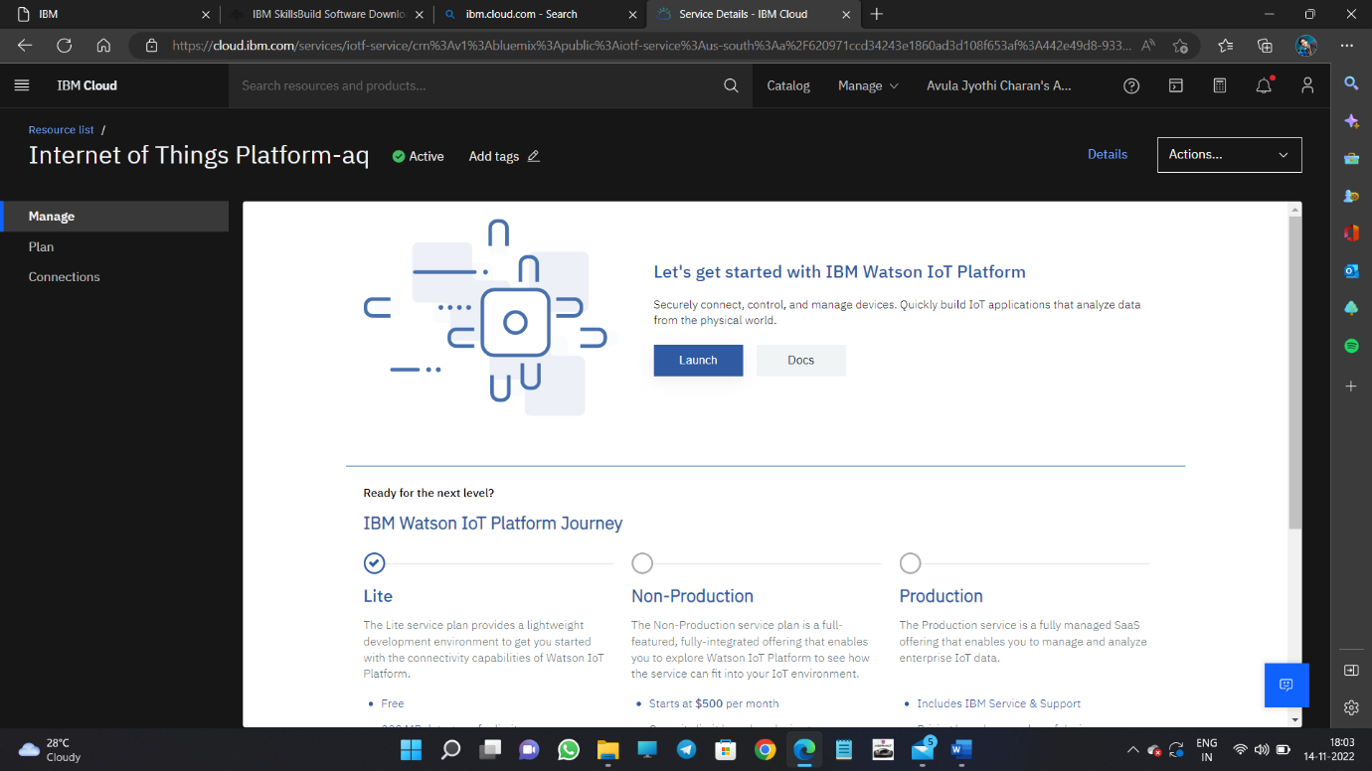

Step-4:IBM Watson IOT platform is created

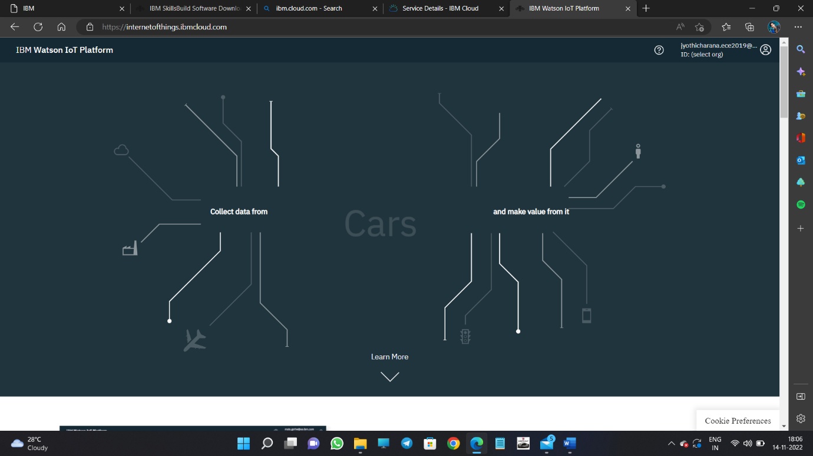

Step-5: In order to connect the IOT device to the IBM cloud,create device in the IBM Watson IOT platform and get the device credentials

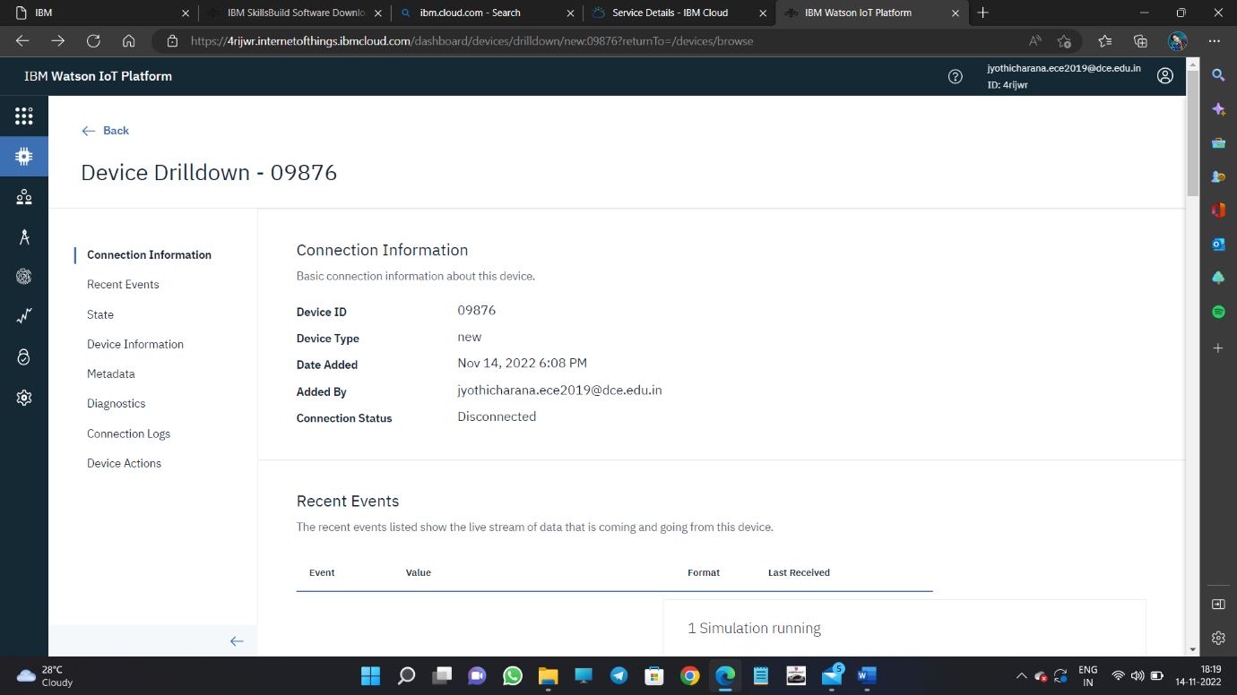

Step-6:Connect the device and start simulating

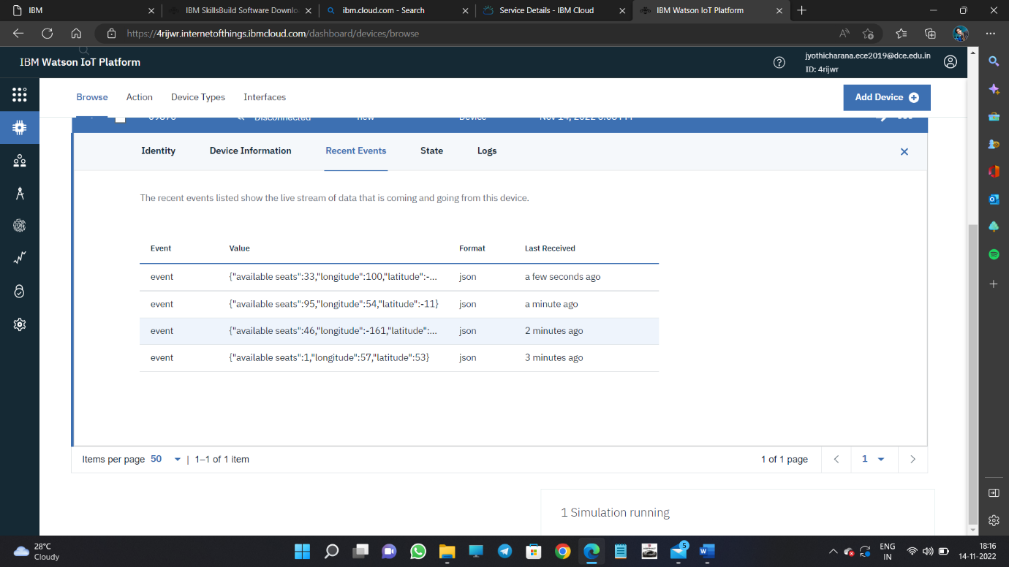

SIMULATION:

The simulation shows the available seats , longitude and latitude

